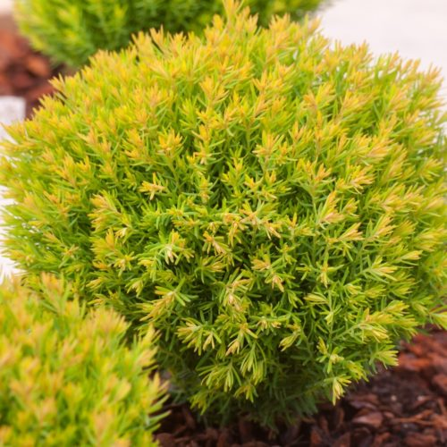
Photo by Dobbies Nursery UK

Siena Sunset Arborvitae Arborvitae Siena Sunset
- Moved to a Condo but still love plants? This itty bitty shrub is perfect for you!

- Nice for small garden spaces or large deck containers where year round color is desired. Good to zone 3 so okay for year round container gardening

- Very slow grower; gets an orange yellow hue in the fall for even more interest

- 18” H x 18” W at full growth

- Prefers rich well-drained soil, consistent moisture in sun to partial sun location

