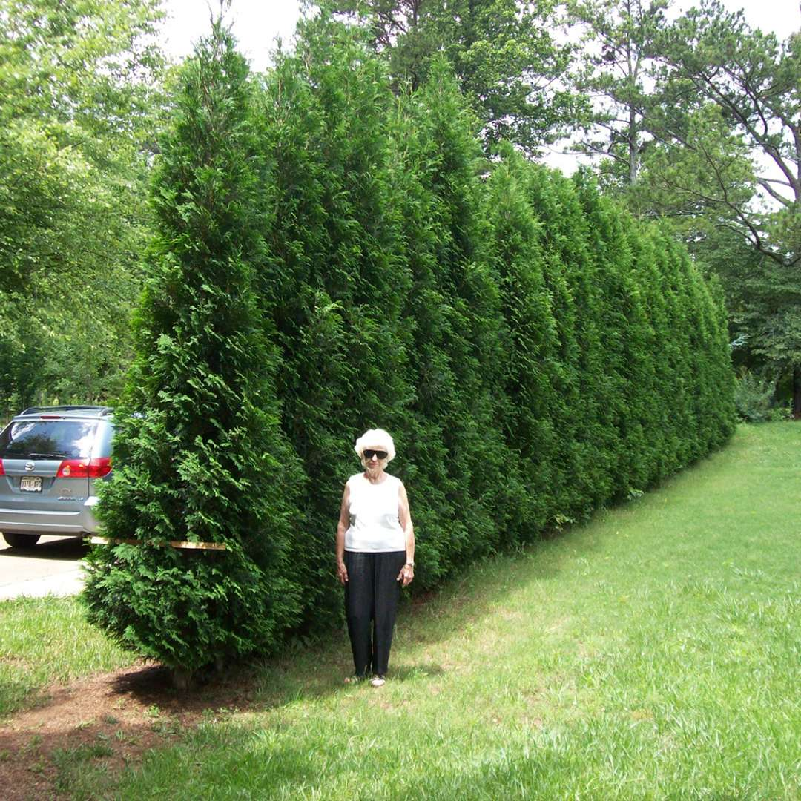
Photo by Spring Meadow Nursery

American Pillar Arborvitae Thuja occidentalis 'American Pillar'
- Very Rapid Grower but keeps it’s dense branching for such a fast grower

- Tall and narrow habit great for privacy

- 25’ H x 4’ W; space 2.5’ apart for dense hedge

- Prefers consistent moisture when young; tolerates heat and drought when established

- Full Sun to partial shade

